Competitors on the Basketball Court: The Rabbi and
the Major League Baseball Player-Manager

by Dr. Eugene Normand

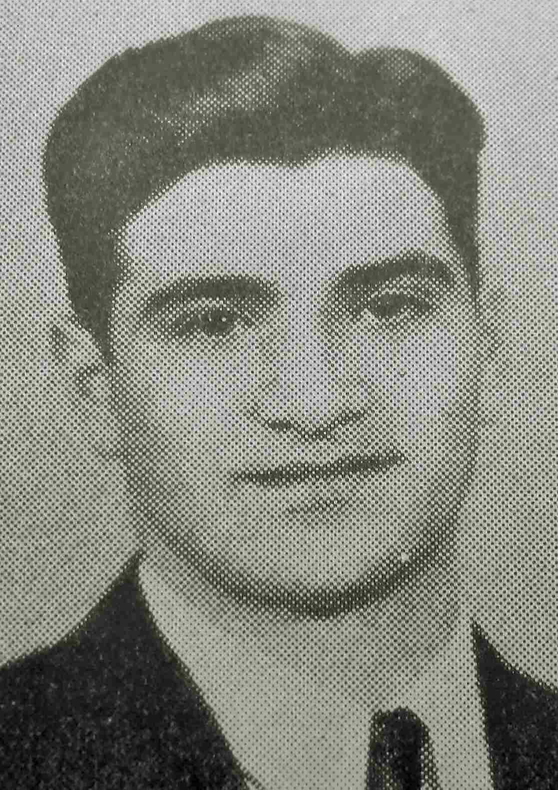
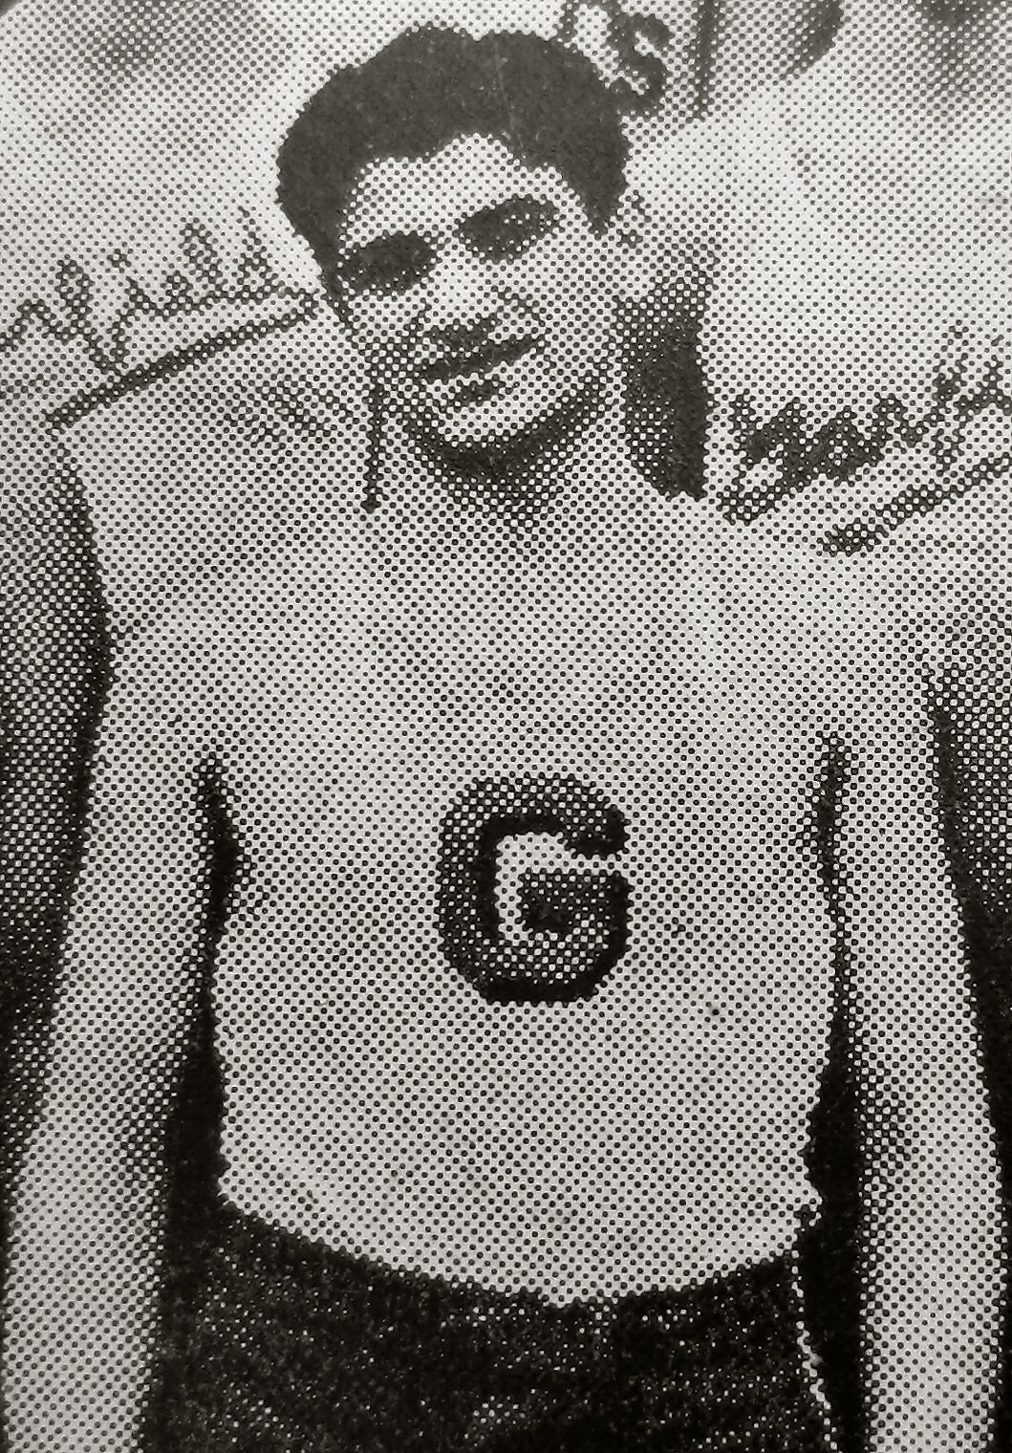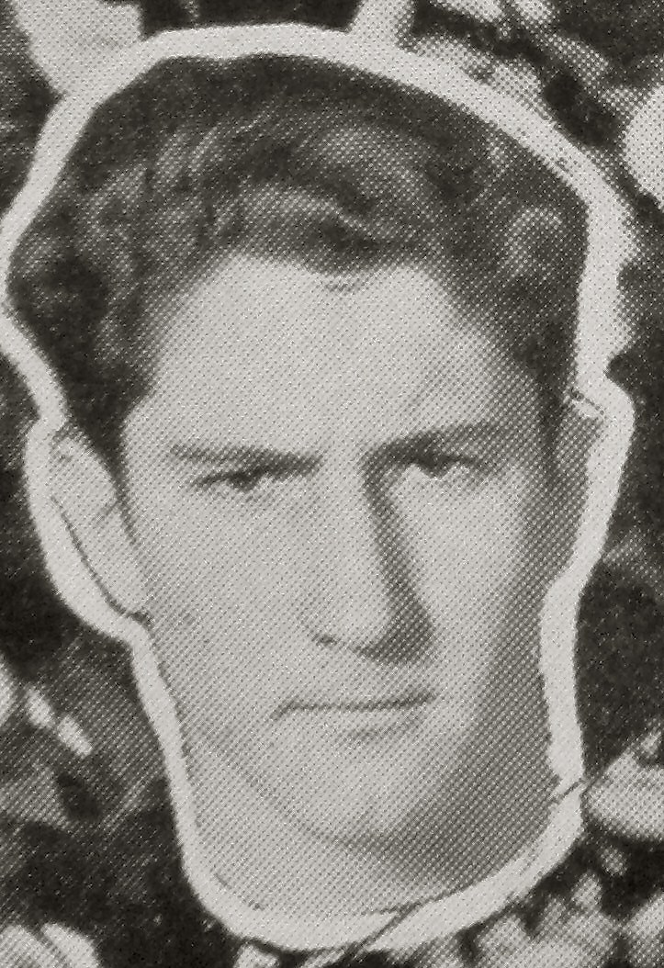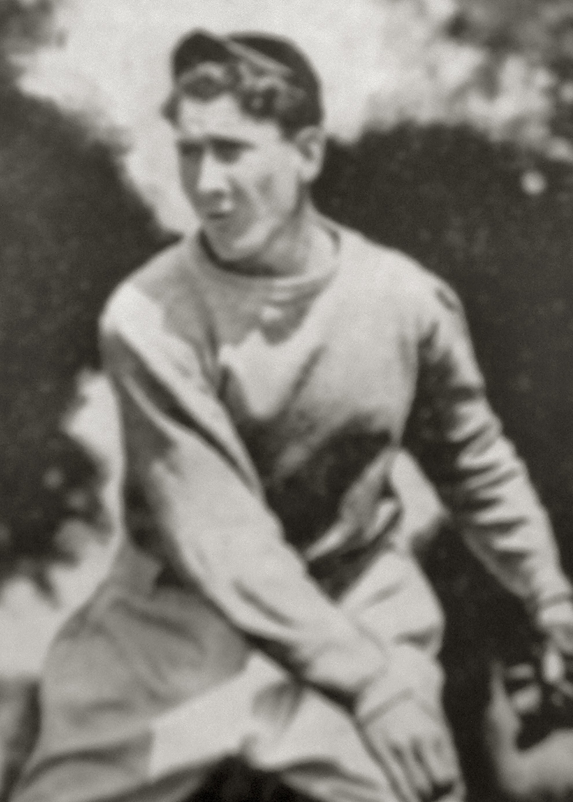
Sol Maimon (Garfield HS basketball) and Fred Hutchinson (Franklin HS, basketball and baseball)

Many of the SBH high school boys were good athletes especially during the 1920s and 30s when almost all of them attended Garfield High School, and for decades afterwards too. A number of them tried out and made the Garfield basketball team. Actually at the time there were usually at least two teams, the varsity and the junior varsity (JV). For Garfield HS during the 1930s it was common for one or two of the starting players on the Garfield basket ball teams to be boys from SBH. The list of such players on the varsity basketball team during this period included: Victor Calderon, Ezra Rose, Israel Halfon, Mordo Barlia and Mike Ovadia.

One who played on the JV team was Solomon Maimon, later to be the rabbi of Congregation Sephardic Bikur Holim, but in those days just a high school boy who was called Sol Maimon. More than 75 years later Rabbi Maimon recalls one of the JV games that he played in, about the year 1935, in which they were playing their rival, Franklin HS. On the Franklin basketball team was one of their star athletes, Frederick Charles "Hutch" Hutchinson.

Like many outstanding athletes Hutch played a number of different sports at highly competitive levels, including basketball and of course baseball, playing all over the baseball field at different times during his career at Franklin as: catcher, pitcher, first baseman and outfielder. In addition he was so good at baseball that he played on two American Legion teams, for Gibson’s Carpet Cleaners and Palace Fish (owned by the Alhadeff family from Cong. Ezra Bessaroth). He went on to play with the Seattle Rainiers minor league team and then pitched for the Detroit Tigers over a 10-year career. Hutch was named manager of the Tigers when he was 32 years old, serving as both a player (pitcher) and manager. At the end of his stint with the Tigers he continued as a manager, of both the St. Louis Cardinals and the Cincinnati Red.

Hutch’s 1961 Reds team won the National League pennant, but lost in the World Series. The Reds were contending again in 1964, when Hutchinson was diagnosed with lung cancer and died that same year. The following year, Hutch’s brother, Dr. Bill Hutchinson, a renowned surgeon, helped to create the Fred Hutchinson Cancer Center as a division of the Pacific Northwest Research Foundation. Since its inception the Hutch has attained an international reputation for its cancer research and advanced cancer treatment and has help to save hundreds of thousands of lives.

Now we will get back to that JV basketball game between Garfield and Franklin in 1935. As Sol Maimon was going for the ball, Hutch was going for it too, and hit Sol in the leg. Sol didn’t care who it was that struck him, he wasn’t going to take it, so he hit Hutch back on his leg. They continued playing the game with no foul being called. One player went on to become the most famous sports and baseball star that Seattle produced, and the other to be the longest practicing rabbi that Seattle has produced.

