Papa, I want to take you to the movies
By Rabbi Solomon Maimon, as told to Eugene Normand
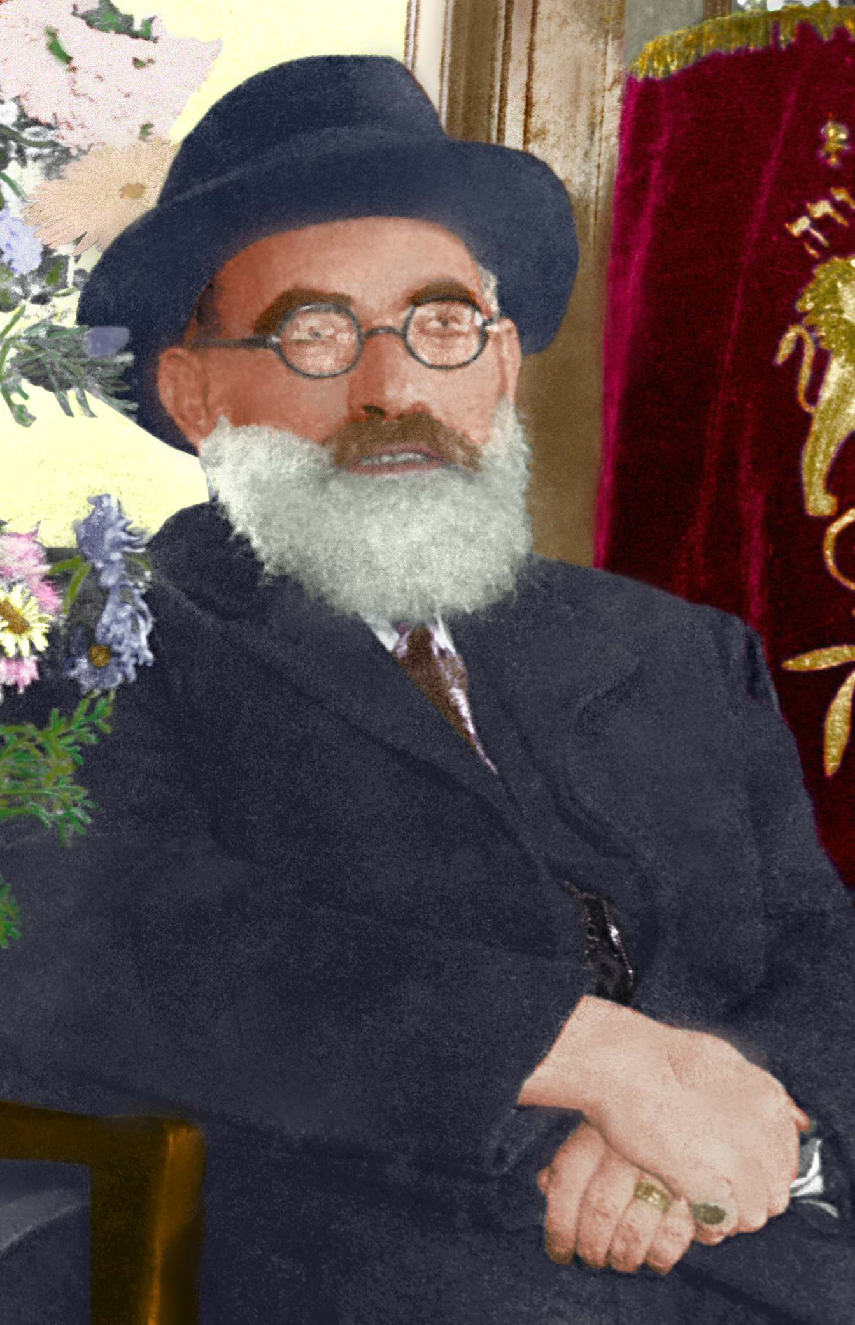
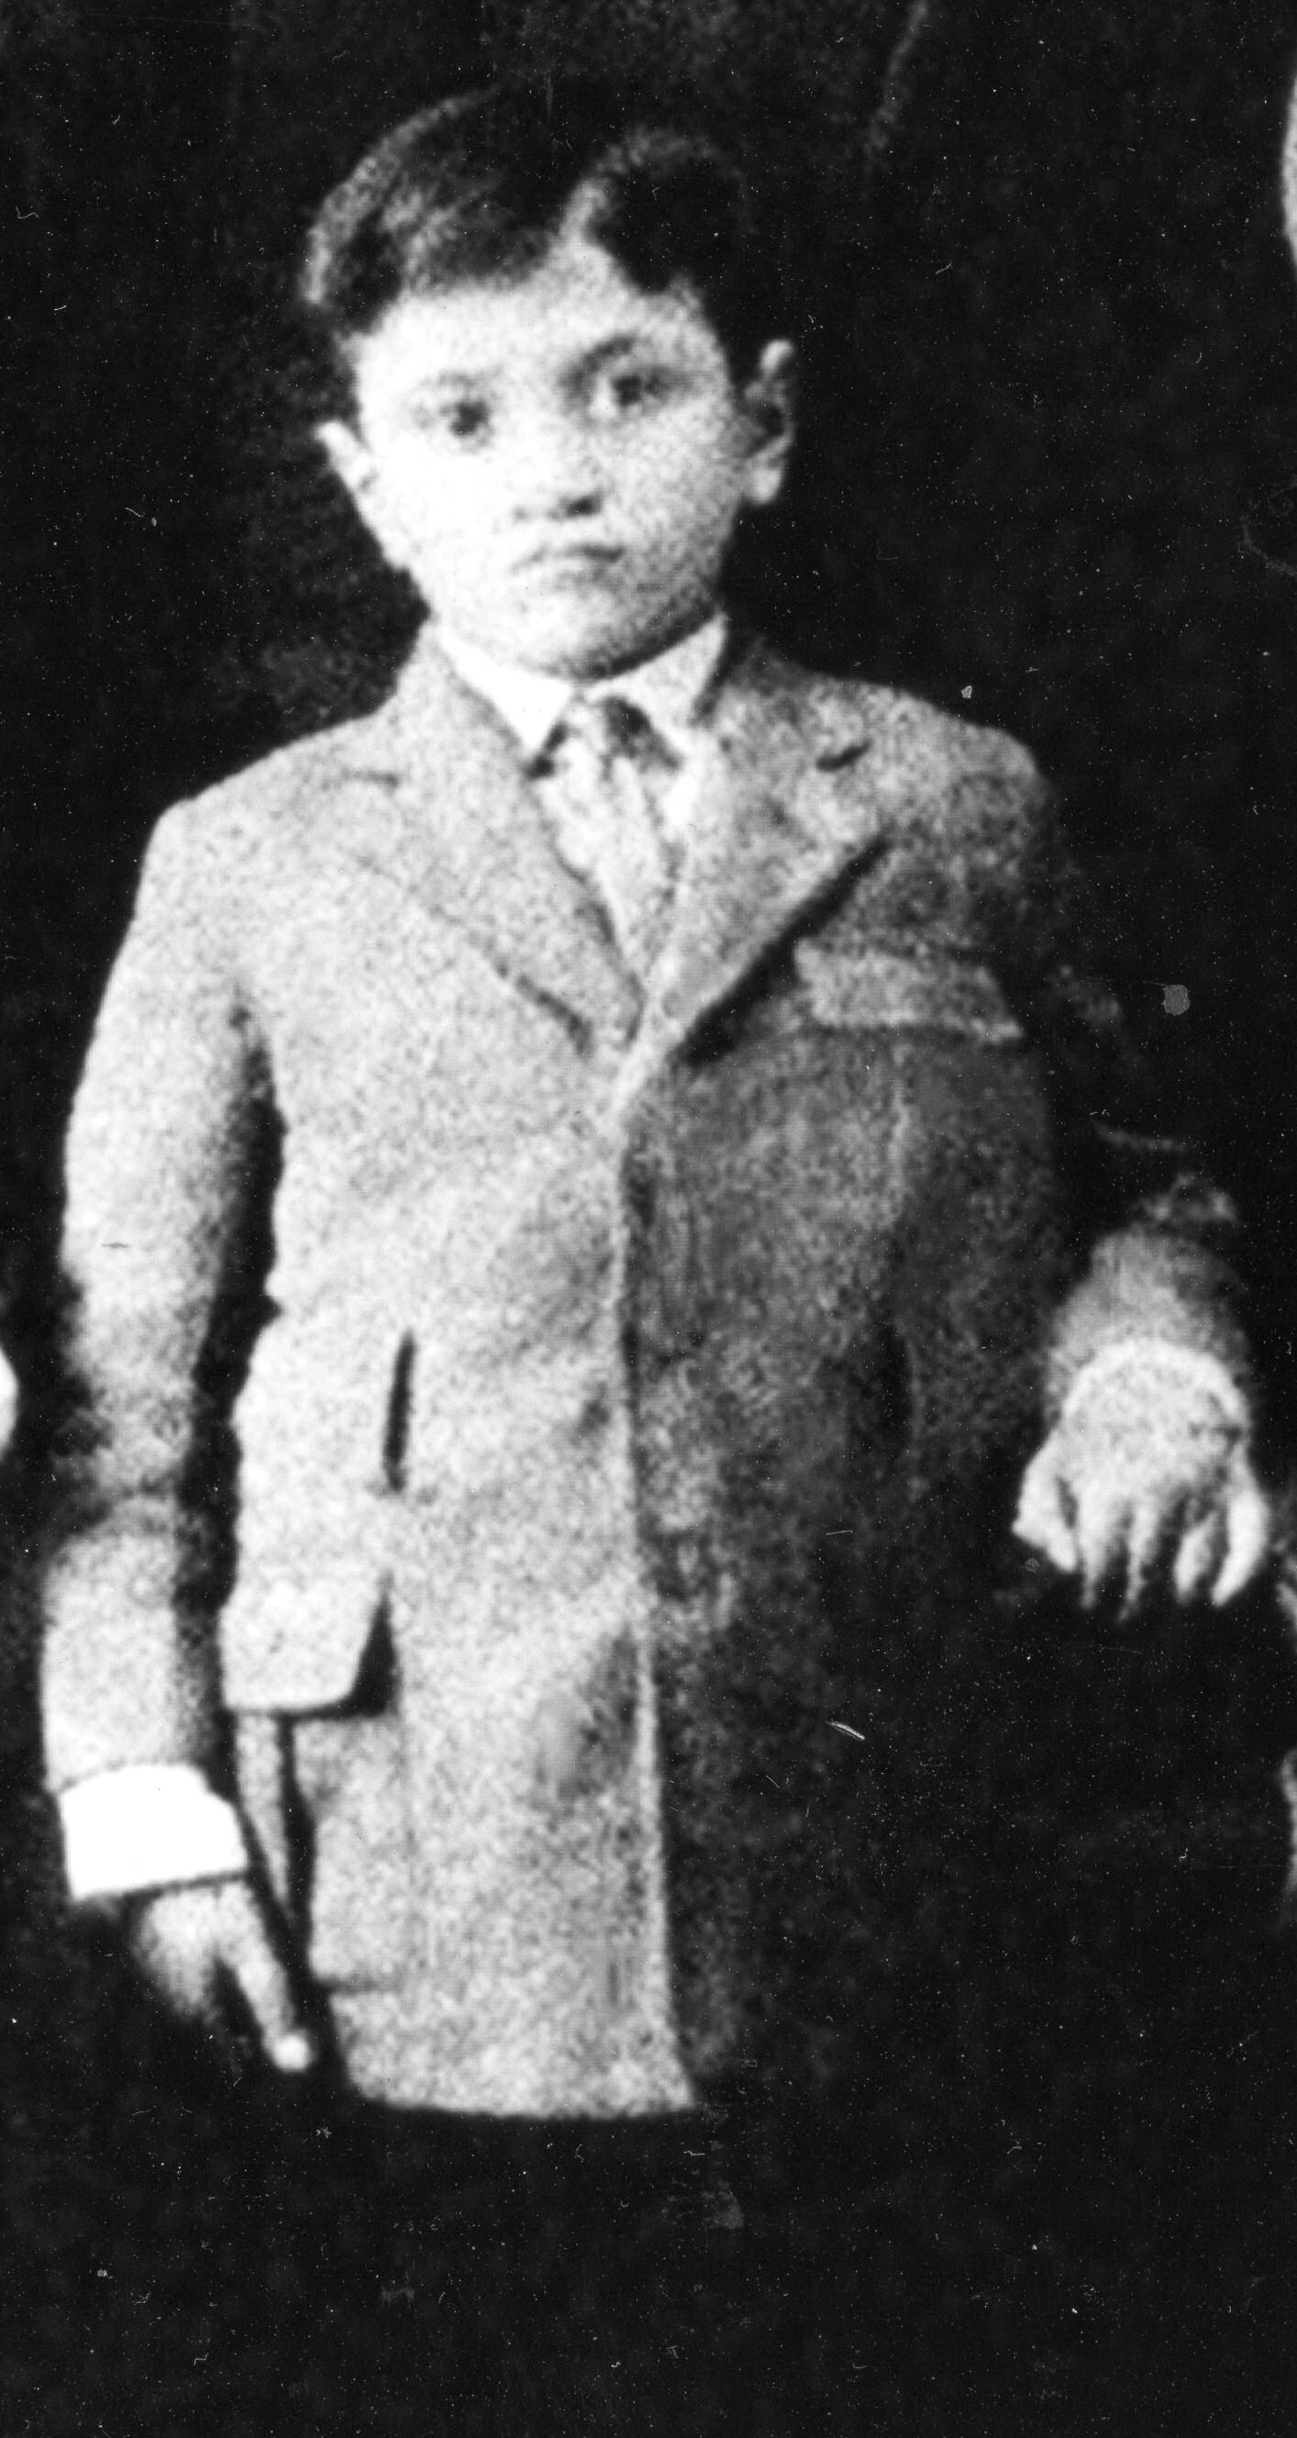
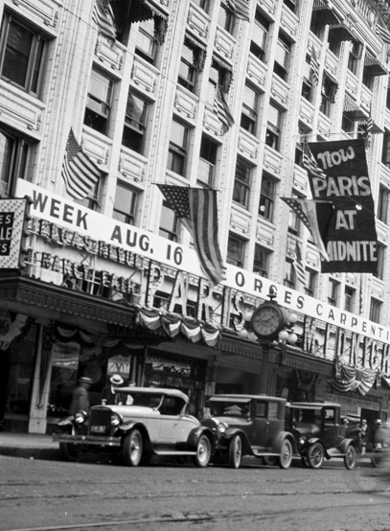

Eleven year old Solomon Maimon had an idea. It was the summer of 1930 in Seattle and he had heard of a famous movie that arrived in the city at the end of July, All Quiet on the Western Front. It was based on the book by Erich Maria Remarque and the film had received acclaim across the country, ostensibly as a war movie about World War I (then known as the Great War). However, in reality it was an anti-war movie that gave a realistic and disturbing picture of the Great War conditions on the battlefield between Germany and France. Thus, the young Solomon invited his father, “Papa, I want to take you to the movies”. Almost 90 years later it is hard to imagine exactly why the eleven year old Solomon chose this movie to invite his father to see, but that is the movie he picked.

As was typical during those days, a movie was shown at only one theater within the city. In Seattle at that time, All Quiet on the Western Front was being shown at the Columbia Theater, downtown, on Second Avenue between Pike and Union.

Movies had gone through a major upheaval during the previous decade. They had been silent (dialogue was displayed on the screen in text format) during most of the 1920s, but after a lot of experimentation, a method had been developed to make the movies talk, i.e., provide synchronized sound for the characters in the movie to speak and sing. The first such talkie, as these films were initially called, was about internal conflicts within a Jewish family. It was The Jazz Singer and it was first released at the end of 1927. It told the story of the fictional Jakie Rabinowitz, a young man with a great singing voice, who defies the traditions of his observant Jewish family and is punished by his father, a noted cantor. This movie starred Al Jolson, who was also Jewish, and included a number of songs ranging from the traditional Kal Nidre to "Toot, Toot, Tootsie (Goo' Bye)" and “Blue Skies”.

With the success of The Jazz Singe”, all of the major Hollywood studios began producing talking movies. Thus, by 1930 when All Quiet on the Western Front came out, it and some of the films from the previous two years were talkies. Most American movie theaters, especially those outside of the larger cities, were still not equipped for sound. Even though the number of cinemas with sound grew from 100 to 800 between 1928 and 1929, they were still a very small percentage of all theaters since the number of silent movie houses at that time was more than 20,000 across the country.

By 1930, most of the theaters in downtown Seattle, including the Columbia and the larger theaters such as the Coliseum and the Orpheum, were all showing talkies. Thus, if you wanted to see a first run talkie movie, you had to ride the street car down to the downtown area where those movie theaters were located. Solomon had never seen a talkie.

That is why the young Solomon, and his father, the revered Rabbi Abraham Maimon, got to the Columbia theater, they rode the trolley car. It was rare for the rabbi to ride the trolley car. In fact, that day, the sight of the rabbi accompanying his son on the trip, made such an impression on the street car conductor that the man wouldn’t take the ten cent fare from him for the trip.

All Quiet on the Western Front was a long movie, well over two hours, so with the very difficult and grimy conditions of the battlefield being shown on the screen, it would have been difficult to sit through all of it. Unfortunately, Haribi Maimon, having served as the rabbi of Tekirdag in Turkey during World War I and the post-war fighting when the Greeks controlled the city, was only too familiar with these kinds of gritty situations that occurred during difficult wartime conditions.

In fact the war movie was so numbing that Rabbi Maimon gradually drifted off to sleep as it played on, but not for too long. Thus, more than half way through the movie, young Solomon felt his father’s elbow gently tapping him in the side. The young boy turned to his father, and the Rabbi whispered one word to him, “Minha”. They got up from their seats, left the theater, and found the streetcar to return them home so that they could be on time for Minha, the afternoon service, at the new Sephardic Bikur Holim sanctuary at 20th Avenue and East Fir Street. Sadly, in less than 6 months, his revered father, Haribi Maimon, would pass away, so this may have been one of the last one-on-one opportunities for the father to be with his youngest son.

