The True Secret of How Crown Royal Whiskey Was Developed
By Rabbi Solomon Maimon, as told to Dr. Eugene Normand

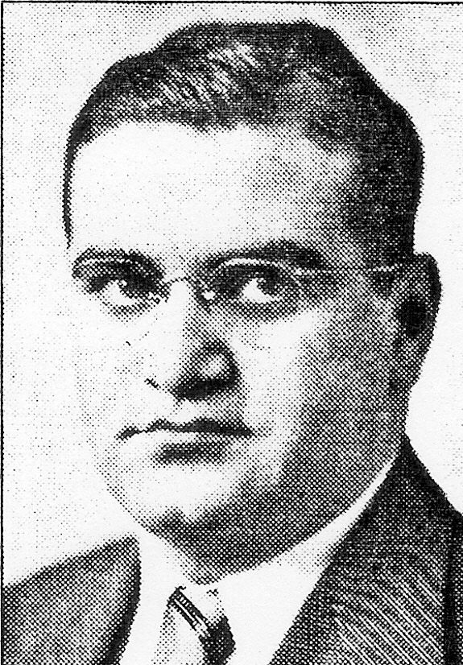
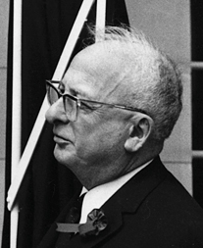
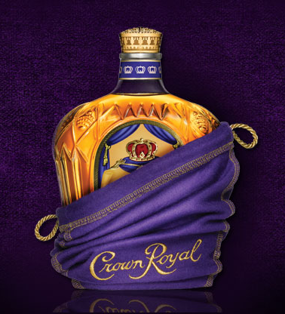

In 1943 the small Sephardic community in Montreal needed a rabbi for a period of time and contacted Yeshiva University. A rabbi at YU (it may have been Rabbi Soloveitchik or Dr. Belkin) told the Canadians that they didn’t have any Sephardim who were ordained (had Semicha), but they did have a senior student, Solomon Maimon, a true Sephardic, who was in the Semicha program and could function as a rabbi for a limited period of time.

The president of Montreal synagogue agreed and so rabbinic student Solomon Maimon took a train up to Montreal. He was there for a period of time. On one particular day, the large Ashkenazic shul was having a special program and invited the Sephardic kehilla to join them. The President of the Sephardic synagogue and his congregants went to the Ashkenazic shul and invited student Maimon to also attend with him. They entered the shul and found that many of the Montreal Jewish community were there.

Student Maimon didn’t know any of the other people so he went off to the side. He saw an older man, close to 60 years old, sitting there so he sat down next to him. The man asked the student if he spoke Yiddish and the response was “Vu den? (What else would you expect?)” The man was Samael Bronfman, the owner of Seagram Co. Ltd.

Little did Bronfman know that seven years earlier the student knew no Yiddish at all, having grown up in a religious Turkish Jewish home. However, in order to survive and prosper as a student at Yeshiva University where many of the Judaic classes were only given in Yiddish, he had to learn Yiddish, which he did. His accent wasn’t the best, so during one class when he was called upon by Rabbi Yosef Soloveichik to respond to a question, the Rabbi said “Du redst vie a Turk -You speak (Yiddish) like a Turk” and in response the class burst out laughing. The puzzled Rabbi asked them why they were laughing. The class told him that Maimon actually was a Turk, having been born in Tekirdag, Turkey.

In Yiddish Mr. Bronfman told the student the story of how he came up with the recipe for his Crown Royal Canadian whiskey. The Governor General in Canada (official British representative in Canada) John Buchan, wanted to encourage Canadian identity in conjunction with their status as a member of the British empire. To accomplish this he conceived of the idea of a royal tour by the British monarchs; King George VI and Queen Elizabeth.

In May 1937 the Canadian Prime Minister, Mackenzie King, was in London for the coronation of the new king, and took the opportunity to consult with the King on such a Canadian tour. It took two years to organize the tour because it was the first visit of a ruling British monarch to the Dominion of Canada. One Canadian official had the idea of asking Mr. Bronfman to develop a new type of Canadian whiskey in honor of the anticipated visit and Mr. Bronfman took up the challenge.

It wasn’t easy. The head brewmaster at Seagrams was first given the job and a few months of experimentation to see if could develop an excellent new whiskey. His results were disappointing. Mr. Bronfman then sent for an outstanding brewmaster from Europe and had him try to come up with a special whiskey, but he too failed. Mr. Bronfman was getting nervous as the time left to him for the royal visit was counting down.

In desperation, Bronfman consulted with his rabbi, explaining the situation and the heavy responsibility that the Canadian government official had put on him. The rabbi suggested to Bronfman that he speak again to his chief brewmaster and explain to him that if he were to come up with a new whiskey it would also have a higher, more spiritual meaning. It would bring joy to Jews of Montreal and all over the world since it would help them enjoy the Shabbos with a new sense of oneg and simcha, i.e., happiness. Bronfman took that idea and relayed the words of encouragement to the brewmaster, who now would be working with additional spiritual motivation to develop a special new whiskey.

It worked. The brewmaster came up with a new, winning recipe for a distinctive and smooth Canadian whiskey which Bronfman called Crown Royal, in honor of the forthcoming visit by the British royal couple. It is also a known symbol in Jewish tradition, the keter malchut, mentioned in the Book of Esther, the royal crown, that was worn in Persia by the king and queen in the days of Queen Esther and King Ahasuerus.

Bronfman was delighted with the new whiskey. Its distinct flavor was admired by all those who drank it, which also allowed him to charge more for it. It also did bring delight to Jews the world over for celebrating on Shabbos and Yom Tovim (Sabbath and Jewish Holy Days).

Once he had the distinctive whiskey, in a sense representing the crown jewel, he needed a luxurious way of presenting it, something connoting royalty and kingship. Bronfman decided on a velvet bag the color of purple, since purple was always associated with royalty. However, some say, that Bronfman was inspired by the look of a tallis or tefilin bag, usually also made of soft velvet for the valuable items kept inside of it.

After telling him this story, no doubt Bronfman offered the student Maimon a l’chaim with some of his Crown Royal whiskey. To this day, seventy years later, Rabbi Solomon Maimon still celebrates Shabbat and Yom Tov with a glass or two of Crown Royal.

http://www.sbhseattle.org/true-secret-crown-royal/

